TWB Observation Target Dec 18, 2014 – Wednesday night / Thursday morning
Beam Steering 15° S, 0° EW On Duty: 0630UTC / 0130 LOCAL

Phase plane at transit 0924 UTC
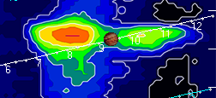

TFD Array 20 MHz HPBW 15° NS x 35° EW
