TWB Observation Target Mar 07, 2015 – Friday night / Saturday morning
Beam Steering 10° S, 0° EW On Duty: 0300UTC / 2200 LOCAL

Phase plane at transit 0341 UTC
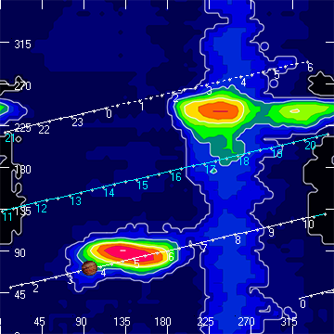

TFD Array 20 MHz HPBW 15° NS x 35° EW
