TWB Observation Target Jan 20, 2015 – Monday night / Tuesday morning
Beam Steering 15° S, 0° EW On Duty: 0530UTC / 0030 LOCAL

Phase plane at transit 0704 UTC
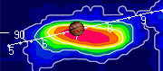

TFD Array 20 MHz HPBW 15° NS x 35° EW
