TWB Observation Report — 17 Jan 2014

Observatory: | AJ4CO Observatory | Instrumentation: | TWB on TFD Array RCP
Location: | High Springs, Florida |  | DPS on TFD Array RCP / LCP
Observer: | Dave Typinski |  | FS-200 on TFD Array RCP+LCP

Observer On Duty (UTC): | 0300 | Body: | Jupiter
Observer Off Duty (UTC): | 0445 | Storm Type: | Io-B

Storm Activity (UTC) |  | CML-III | Io φ | Off Axis | D_{E} | JS ∠ | Δ JE
Begin: | 0400 | 98° | 102° | 12° | +1.64° | +167° | 4.23 AU
End: | 0435 | 120° | 107° | 7° | +1.64° | +167° | 4.23 AU

Interval |  |  |  |  |  | F_{hi} | F_{lo} |  |  |  | Drift |  | Rot Rate | TEC
# | (UTC) | L | S | N | Pol | MHz | MHz | CML | Io | ML | MHz/sec | FB | #/MHz @ F | 10¹⁶/m²
1 | 0400–0435 | X | X | X | RCP | 17 | 33 | 109° | 105° |  |  |  |  | 8.8
2
3
4
5
6

Interval – Time during which something interesting was observed  L, S, N – Indicates presence of L bursts, S bursts, and N events  Pol – Dominant circular polarization observed  Fhi, Flo – Frequency range of observed emission  CML, Io – System III CML and Io phase during noted interval | ML – indicates presence of modulation lanes  Drift – Observed modulation lane drift rate in MHz per minute  FB – indicates presence of Faraday bands  Rot Rate – Observed Faraday rotation rate in rotations per MHz at observing frequency F  TEC – Ionospheric vertical total electron count during noted interval as reported by NGDC

Observer Notes
Almost all L bursting. Very brief period of what sounded like S bursting circa 0425–0430.

Data File(s): | 4 Gage data files  AJ4CO-DPS-140117035500.sps  AJ4CO-FS-200-140117035500.sps

Io-CML Phase Plane

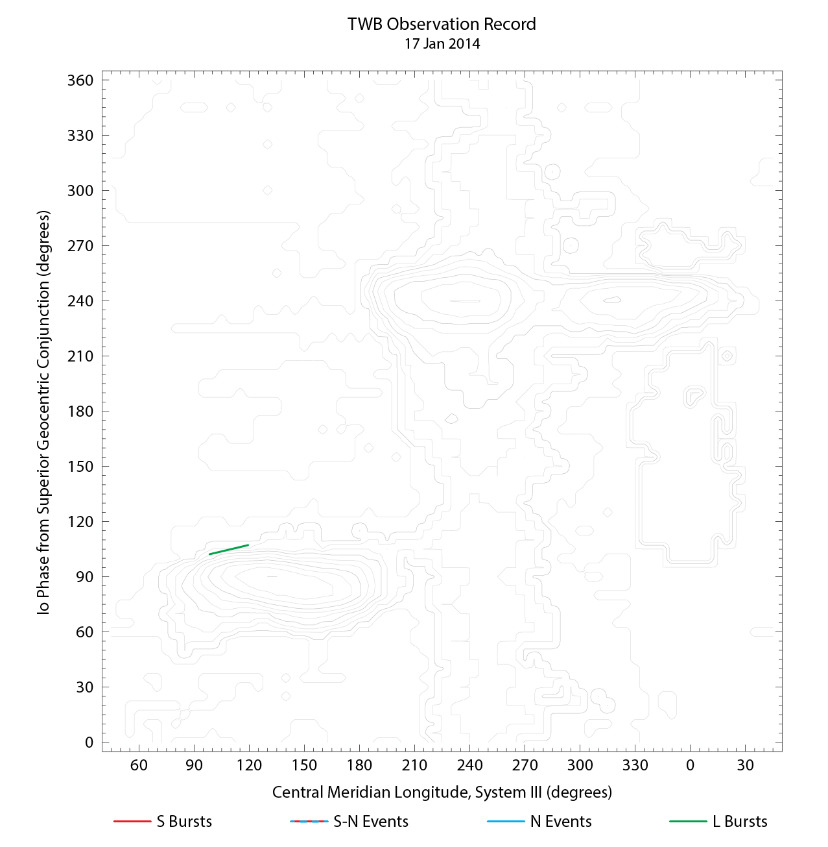

RJP Sky View

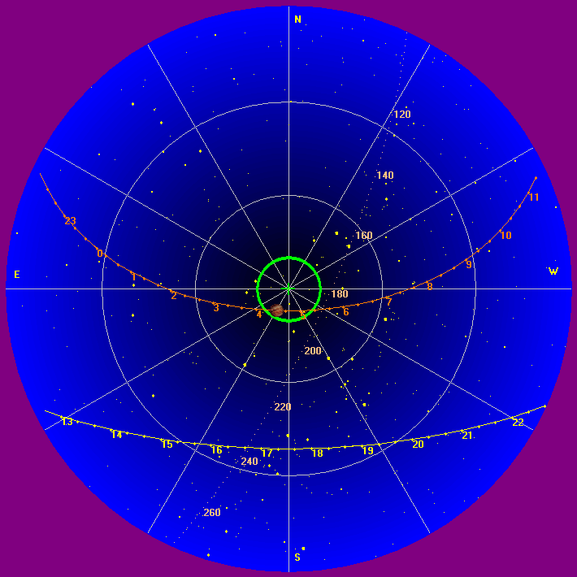

US-TEC Map
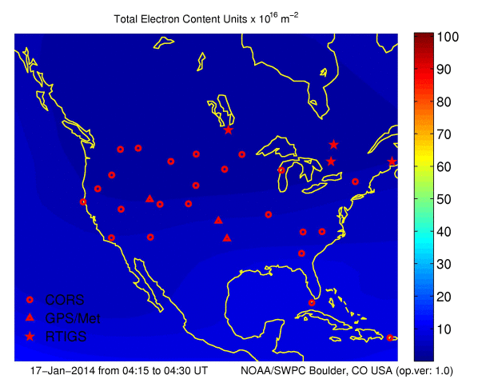
Kp index, 3-hour average: | 1

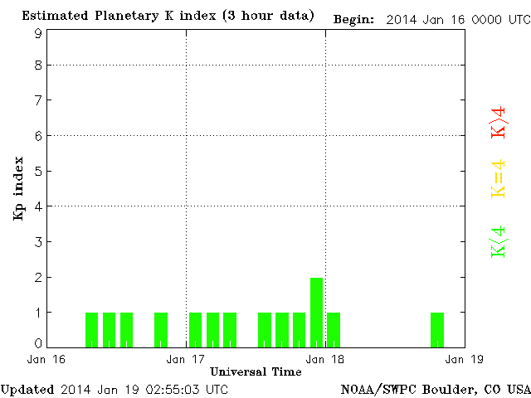

CONUS Lightning Activity

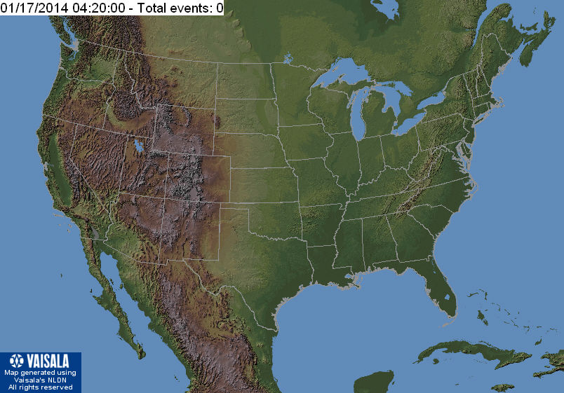

Instrumentation: | DPS on XTFD  60 kHz IF  300 channels, 53 kHz spacing  17–33 MHz

Calibration Scale

Overview Spectrograms (700 px)

