TWB Observation Report — 30 Dec 2013

Observatory: | AJ4CO Observatory | Instrumentation: | TWB on TFD Array RCP
Location: | High Springs, Florida |  | DPS on TFD Array RCP / LCP
Observer: | Dave Typinski |  | FS-200 on TFD Array RCP+LCP

Observer On Duty (UTC): | 0830 | Body: | Jupiter
Observer Off Duty (UTC): | 1200 | Storm Type: | Io-B

Storm Activity (UTC) |  | CML-III | Io φ | Off Axis | D_{E} | JS ∠ | Δ JE
Begin: | 0910 | 94° | 81° | 3° | +1.62° | –173° | 4.21 AU
End: | 1120 | 136° | 91° | 30° | +1.62° | –173° | 4.21 AU

Interval |  |  |  |  |  | F_{hi} | F_{lo} |  |  |  | Drift |  | Rot Rate | TEC
# | (UTC) | L | S | N | Pol | MHz | MHz | CML | Io | ML | MHz/sec | FB | #/MHz @ F | 10¹⁶/m²
1 | 0910–1020 |  | X |  | RCP | 17 | 28 | 115° | 86° |  |  |  |  | 13.5
2 | 1020–1120 | X |  |  | RCP | 17 | 31 | 154° | 96° |  |  |  |  | 14.2
3
4
5
6

Interval – Time during which something interesting was observed  L, S, N – Indicates presence of L bursts, S bursts, and N events  Pol – Dominant circular polarization observed  Fhi, Flo – Frequency range of observed emission  CML, Io – System III CML and Io phase during noted interval | ML – indicates presence of modulation lanes  Drift – Observed modulation lane drift rate in MHz per minute  FB – indicates presence of Faraday bands  Rot Rate – Observed Faraday rotation rate in rotations per MHz at observing frequency F  TEC – Ionospheric vertical total electron count during noted interval as reported by NGDC

Observer Notes
RCP emission visible from 17 to 31 MHz.
Lots of S bursting from 0920 to 1010 UTC. Pretty much all L bursting after that, a little overlap of both in between. Nice modulation lanes after 1030.

Data File(s): | 22 Gage data files  AJ4CO-DPS-131229090000.sps  AJ4CO-FS-200-131229090000.sps

Io-CML Phase Plane

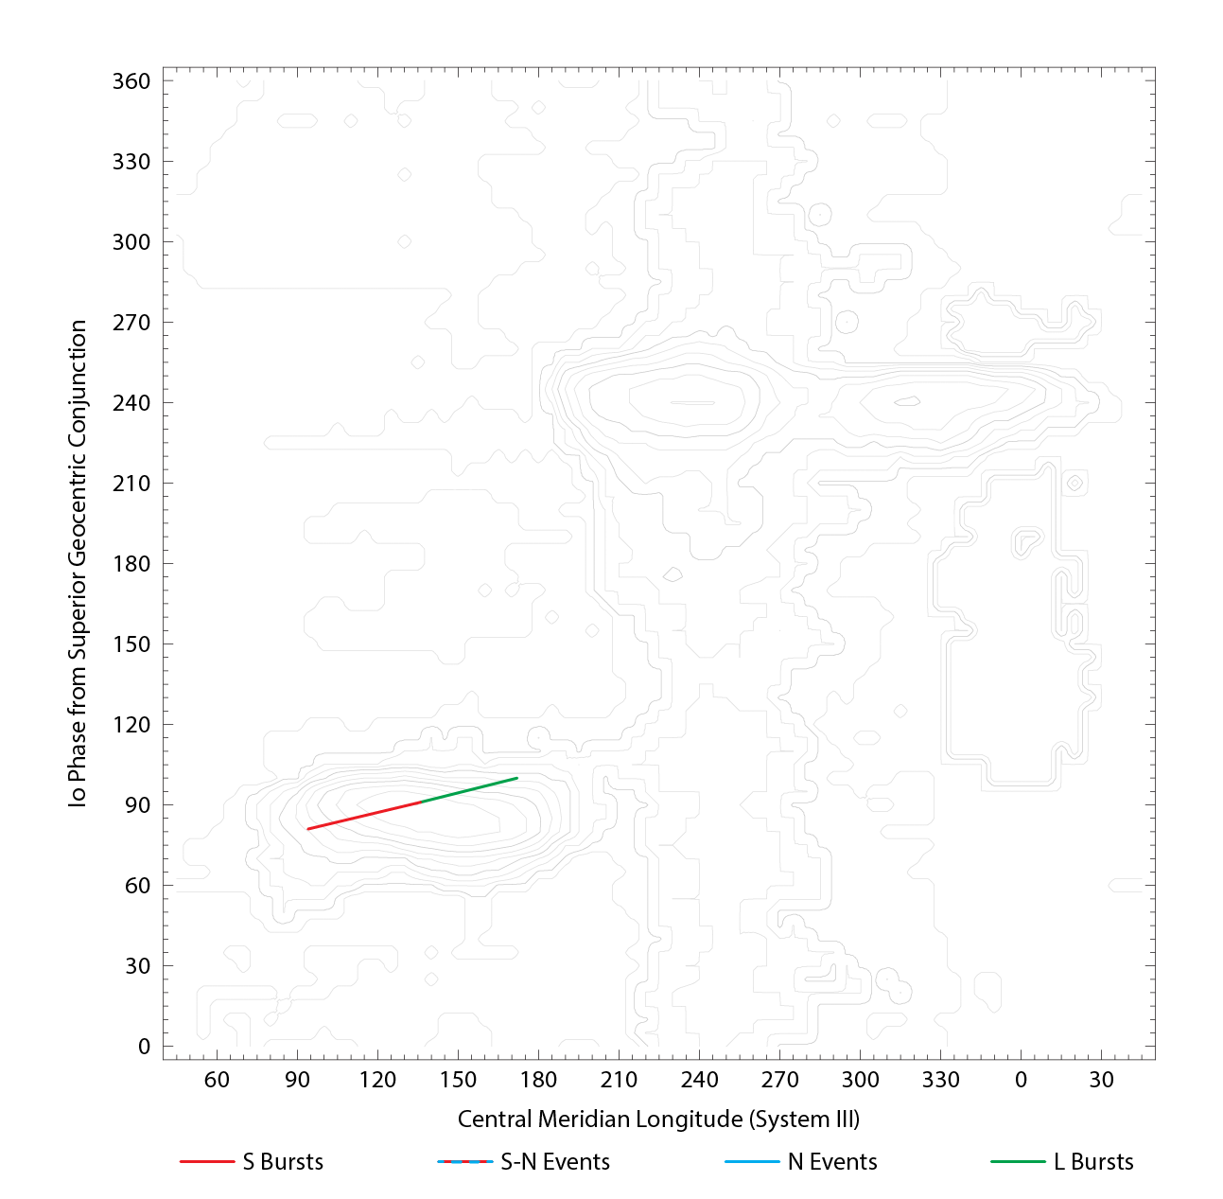

RJP Sky View

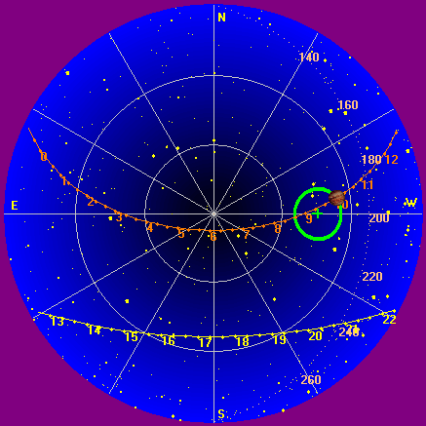

US-TEC Map
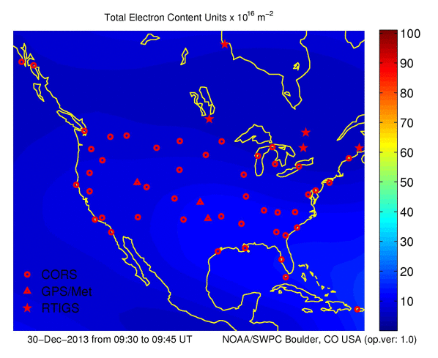
Kp index, 3-hour average: | 1

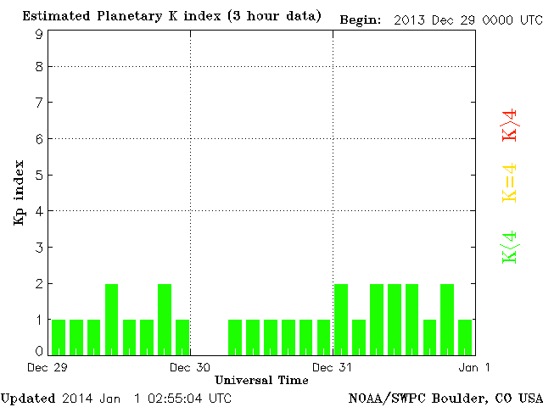

CONUS Lightning Activity

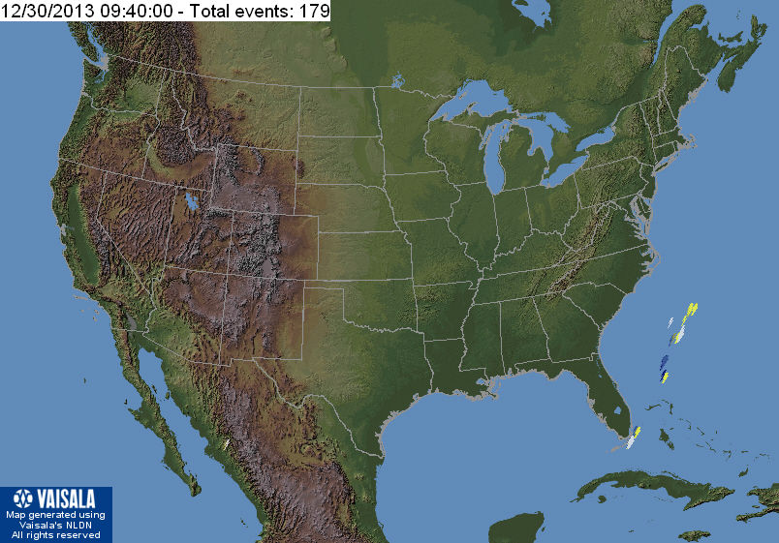

Instrumentation: | DPS on XTFD  60 kHz IF  300 channels, 53 kHz spacing  17–33 MHz

Calibration Scale

Overview Spectrograms (700 px)

