TWB Observation Report — 23 Dec 2013

Observatory: | AJ4CO Observatory | Instrumentation: | TWB on TFD Array RCP
Location: | High Springs, Florida |  | DPS on TFD Array RCP / LCP
Observer: | Dave Typinski |  | FS-200 on TFD Array RCP+LCP

Observer On Duty (UTC): | 0740 | Body: | Jupiter
Observer Off Duty (UTC): | 0955 | Storm Type: | Io-B

Storm Activity (UTC) |  | CML-III | Io φ | Off Axis | D_{E} | JS ∠ | Δ JE
Begin: | 0800 | 77° | 86° | 12° | +1.62° | –164° | 4.23 AU
End: | 0950 | 143° | 101° | 14° | +1.62° | –164° | 4.23 AU

Interval |  |  |  |  |  | F_{hi} | F_{lo} |  |  |  | Drift |  | Rot Rate | TEC
# | (UTC) | L | S | N | Pol | MHz | MHz | CML | Io | ML | MHz/sec | FB | #/MHz @ F | 10¹⁶/m²
1 | 0910–0950 |  | X |  | RCP | 24 | 32 | 131° | 99° |  |  |  |  | 13.5
2
3
4
5
6

Interval – Time during which something interesting was observed  L, S, N – Indicates presence of L bursts, S bursts, and N events  Pol – Dominant circular polarization observed  Fhi, Flo – Frequency range of observed emission  CML, Io – System III CML and Io phase during noted interval | ML – indicates presence of modulation lanes  Drift – Observed modulation lane drift rate in MHz per minute  FB – indicates presence of Faraday bands  Rot Rate – Observed Faraday rotation rate in rotations per MHz at observing frequency F  TEC – Ionospheric vertical total electron count during noted interval as reported by NGDC

Observer Notes
Emission consisted of primarily L bursts visible from 17 to 33 MHz, from 0800 to 0950 UTC.
From 0910 to 0950, there was a period of S bursting, primarily from 24 to 28 MHz, but went as high as 32 MHz.
This was a very strong event, coming close to 2 MK in the Jove receivers on the TFD array -- about 10 dB hotter than previous storms this season.
This storm exhibited very pronounced modulation lanes with positive and negative drift rates, often simultaneously.

Data File(s): | 32 Gage data files  AJ4CO-DPS-131223080000.sps  AJ4CO-FS-200-131223100000.sps

Io-CML Phase Plane

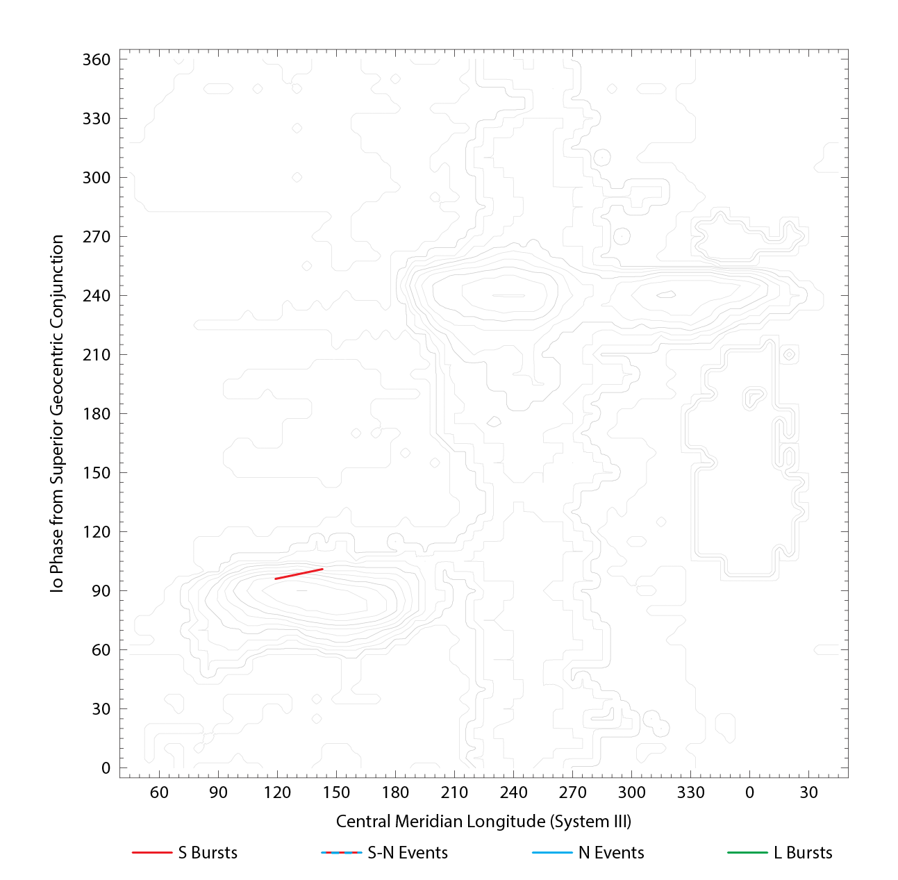

RJP Sky View

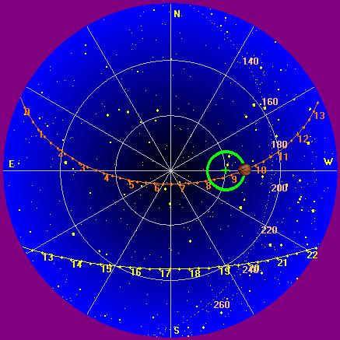

US-TEC Map
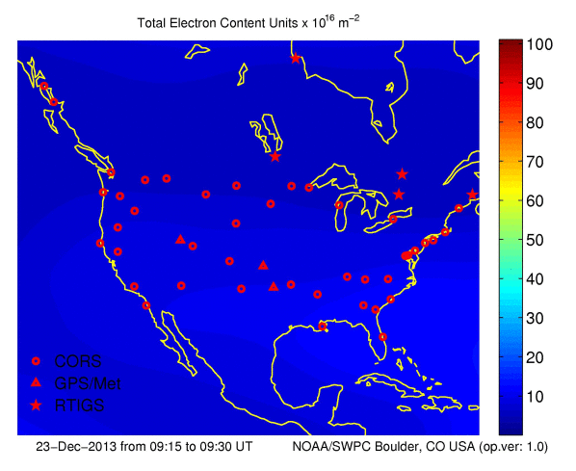
Kp index, 3-hour average: | 0

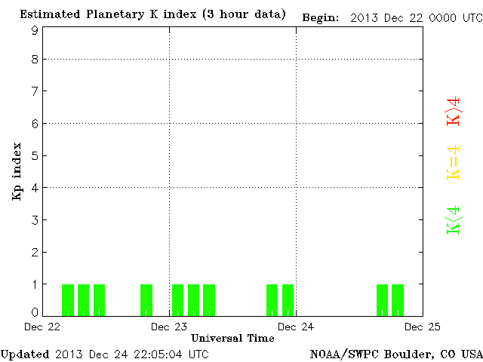

CONUS Lightning Activity

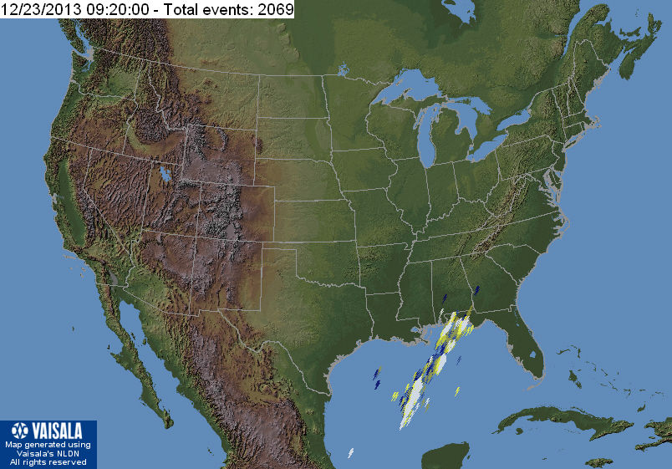

Instrumentation: | DPS on XTFD  60 kHz IF  300 channels, 53 kHz spacing  17–33 MHz

Calibration Scale

Overview Spectrograms (700 px)

