TWB Observation Report — 07 Dec 2013

Observatory: | AJ4CO Observatory | Instrumentation: | TWB on TFD Array RCP
Location: | High Springs, Florida |  | Gage CS1220 Digitizer
Observer: | Dave Typinski |  | DPS on TFD Array

Observer On Duty (UTC): | 0610 | Body: | Jupiter
Observer Off Duty (UTC): | 0800 | Storm Type: | Io-B

Storm Activity (UTC) |  | CML-III | Io φ | Off Axis | D_{E} | JS ∠ | Δ JE
Begin: | 0727 | 164° | 63° | 9° | +1.61° | –146° | 4.33 AU
End: | 0742 | 176° | 65° | 8° | +1.61° | –146° | 4.33 AU

Interval |  |  |  |  |  | F_{hi} | F_{lo} |  |  |  | Drift |  | Rot Rate | TEC
# | (UTC) | L | S | N | Pol | MHz | MHz | CML | Io | S | MHz/sec | FB | #/MHz @ F | 10¹⁶/m²
1 | 0727–0742 |  | X | X | RCP | 17.4 | 17.0 | 170° | 64° |  |  |  |  | 16.3
2
3
4
5
6

Interval – Time during which something interesting was observed  L, S, N – Indicates presence of L bursts, S bursts, and N events  Pol – Dominant circular polarization observed  Fhi, Flo – Frequency range of observed emission  CML, Io – System III CML and Io phase during noted interval | ML – indicates presence of modulation lanes  Drift – Observed modulation lane drift rate in MHz per minute  FB – indicates presence of Faraday bands  Rot Rate – Observed Faraday rotation rate in rotations per MHz at observing frequency F  TEC – Ionospheric vertical total electron count during noted interval as reported by NGDC

Observer Notes
Many S-N events, also some plain N events (narrow band L bursts). A few brief sessions of S bursting at lower frequencies. All RCP dominant emission.

Data File(s): | AJ4CO-DPS-131207072000.sps  plus 2 Gage SPS data files

Custom Interval Ephemerides
 | Start Dates: | 12/7/13 |  |  |  | 12/7/13
 | & End Times: | 07:24:00 |  |  |  | 07:43:00
 |  | Interval Start |  | Interval Center |  | Interval End
Date |  | 07 Dec 2013 |  | 07 Dec 2013 |  | 07 Dec 2013
UTC |  | 07:24:00 |  | 07:33:30 |  | 07:43:00
JDE |  | 2456633.80913 |  | 2456633.81572 |  | 2456633.82232
Local (UTC-4) |  | 03:24:00 |  | 03:33:30 |  | 03:43:00
LMST |  | 06:58:26 |  | 07:07:58 |  | 07:17:29
 |  | Jupiter |  | Jupiter |  | Jupiter
Alt ° |  | +80.610 |  | +81.652 |  | +82.232
Az ° |  | +143.552 |  | +156.212 |  | +171.453
HA hms |  | - 00:24:02 |  | - 00:14:30 |  | - 00:04:58
Off Axis ° |  | +9.390 |  | +8.348 |  | +7.768
RA hms |  | - 16:37:31.9607 |  | - 16:37:32.1195 |  | - 16:37:32.2784
Dec ° |  | +22.1495983 |  | +22.1497010 |  | +22.1498037
Rise UTC |  | 0053 (2053 L) |  | 0053 (2053 L) |  | 0053 (2053 L)
Trans UTC |  | 0747 (0347 L) |  | 0747 (0347 L) |  | 0747 (0347 L)
Set UTC |  | 1441 (1041 L) |  | 1441 (1041 L) |  | 1441 (1041 L)
De ° |  | +1.61174565 |  | +1.61174565 |  | +1.61174564
Δ J-E AU |  | +4.33437023 |  | +4.33431479 |  | +4.33425937
J-E ∠° |  | +27.63064 |  | +27.62449 |  | +27.61834
€
Ds ° |  | +1.76689810 |  | +1.76687330 |  | +1.76684850
Δ J-S AU |  | +5.183057497 |  | +5.183059934 |  | +5.183062370
J-S ∠° |  | - 146.31836 |  | - 146.32568 |  | - 146.33300
CML-III ° |  | +164.130 |  | +169.874 |  | +175.618
Io SGC ° |  | +62.473 |  | +63.819 |  | +65.166
Io λ (III) °

Io-CML Phase Plane

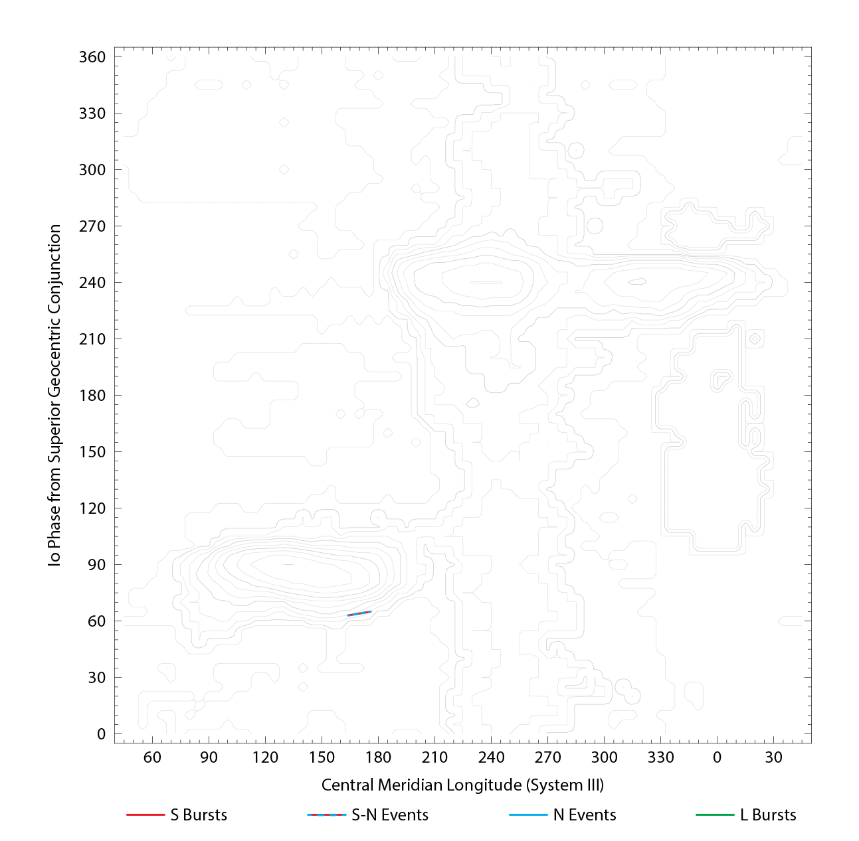

RJP Sky View

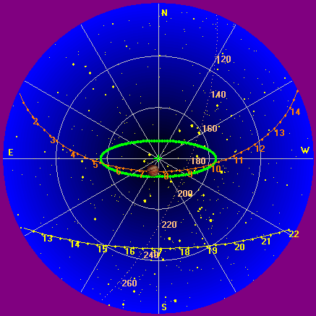

US-TEC Map

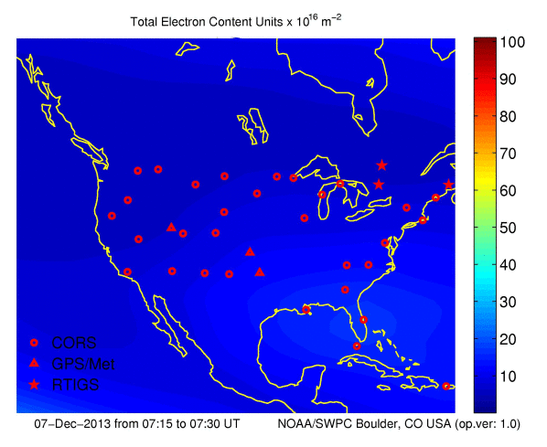

Kp index, 3-hour average: | 1

CONUS Lightning Activity

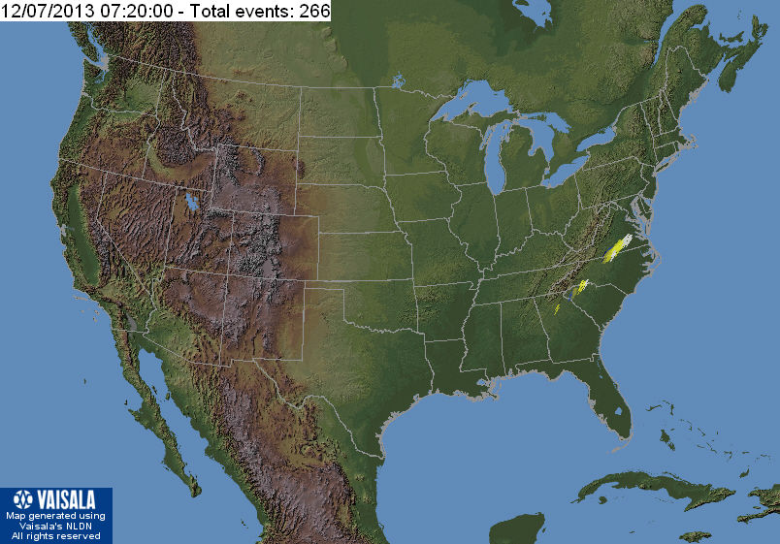

Instrumentation: | DPS on XTFD  60 kHz IF  300 channels, 53 kHz spacing  17–33 MHz

Calibration Scale

Overview Spectrogram (700 px)

