TWB Observation Report — 30 Nov 2013

Observatory: | AJ4CO Observatory | Instrumentation: | TWB on E-W TFD Array Elements
Location: | High Springs, Florida |  | Gage CS1220 Digitizer
Observer: | Dave Typinski |  | DPS on XTFD Array

Observer On Duty (UTC): | 0330 | Body: | Jupiter
Observer Off Duty (UTC): | 0800 | Storm Type: | Io-B

Storm Activity (UTC) |  | CML-III | Io φ | Off Axis | D_{E} | JS ∠ | Δ JE
Begin: | 0558 | 134° | 64° | 32° | +1.61° | –139° | 4.40 AU
End: | 0707 | 179° | 75° | 20° | +1.61° | –139° | 4.40 AU

Interval |  |  |  |  |  | F_{hi} | F_{lo} |  |  |  | Drift |  | Rot Rate | TEC
# | (UTC) | L | S | N | Pol | MHz | MHz | CML | Io | ML | MHz/m | FB | #/MHz @ F | 10¹⁶/m²
1 | 0558–0707 |  | X | X | RCP | 17 | 23 | 157° | 70° |  |  |  |  | 18.4
2
3
4
5
6

Interval – Time during which something interesting was observed  L, S, N – Indicates presence of L bursts, S bursts, and N events  Pol – Dominant circular polarization observed  Fhi, Flo – Frequency range of observed emission  CML, Io – System III CML and Io phase during noted interval | ML – indicates presence of modulation lanes  Drift – Observed modulation lane drift rate in MHz per minute  FB – indicates presence of Faraday bands  Rot Rate – Observed Faraday rotation rate in rotations per MHz at observing frequency F  TEC – Ionospheric vertical total electron count during noted interval as reported by NGDC

Observer Notes
Many S-N events, also some plain N events (narrow band L bursts). A few brief sessions of S bursting at lower frequencies. All RCP dominant emission.

Data File(s): | AJ4CO-DPS-131130054500.sps  plus 19 Gage SPS data files

Custom Interval Ephemerides
 | Start Dates: | 11/30/13 |  |  |  | 11/30/13
 | & End Times: | 05:52:00 |  |  |  | 07:07:00
 |  | Interval Start |  | Interval Center |  | Interval End
Date |  | 30 Nov 2013 |  | 30 Nov 2013 |  | 30 Nov 2013
UTC |  | 05:52:00 |  | 06:29:30 |  | 07:07:00
JDE |  | 2456626.74524 |  | 2456626.77128 |  | 2456626.79732
Local (UTC-4) |  | 01:52:00 |  | 02:29:30 |  | 03:07:00
LMST |  | 04:58:35 |  | 05:36:12 |  | 06:13:48
 |  | Jupiter |  | Jupiter |  | Jupiter
Alt ° |  | +56.325 |  | +64.402 |  | +72.230
Az ° |  | +94.610 |  | +101.280 |  | +111.820
HA hms |  | - 02:26:25 |  | - 01:48:49 |  | - 01:11:12
Off Axis ° |  | +33.675 |  | +25.598 |  | +17.770
RA hms |  | - 16:34:59.4205 |  | - 16:34:59.9155 |  | - 16:35:00.4111
Dec ° |  | +22.0480337 |  | +22.0483743 |  | +22.0487153
Rise UTC |  | 0124 (2124 L) |  | 0124 (2124 L) |  | 0124 (2124 L)
Trans UTC |  | 0818 (0418 L) |  | 0818 (0418 L) |  | 0818 (0418 L)
Set UTC |  | 1511 (1111 L) |  | 1511 (1111 L) |  | 1511 (1111 L)
De ° |  | +1.61327632 |  | +1.61326488 |  | +1.61325348
Δ J-E AU |  | +4.39988102 |  | +4.39961787 |  | +4.39935489
J-E ∠° |  | +34.20722 |  | +34.18300 |  | +34.15879
€
Ds ° |  | +1.79337117 |  | +1.79327387 |  | +1.79317657
Δ J-S AU |  | +5.180449292 |  | +5.180458906 |  | +5.180468520
J-S ∠° |  | - 138.55327 |  | - 138.58161 |  | - 138.60995
CML-III ° |  | +133.832 |  | +156.506 |  | +179.179
Io SGC ° |  | +64.343 |  | +69.656 |  | +74.973
Io λ (III) °

Io-CML Phase Plane

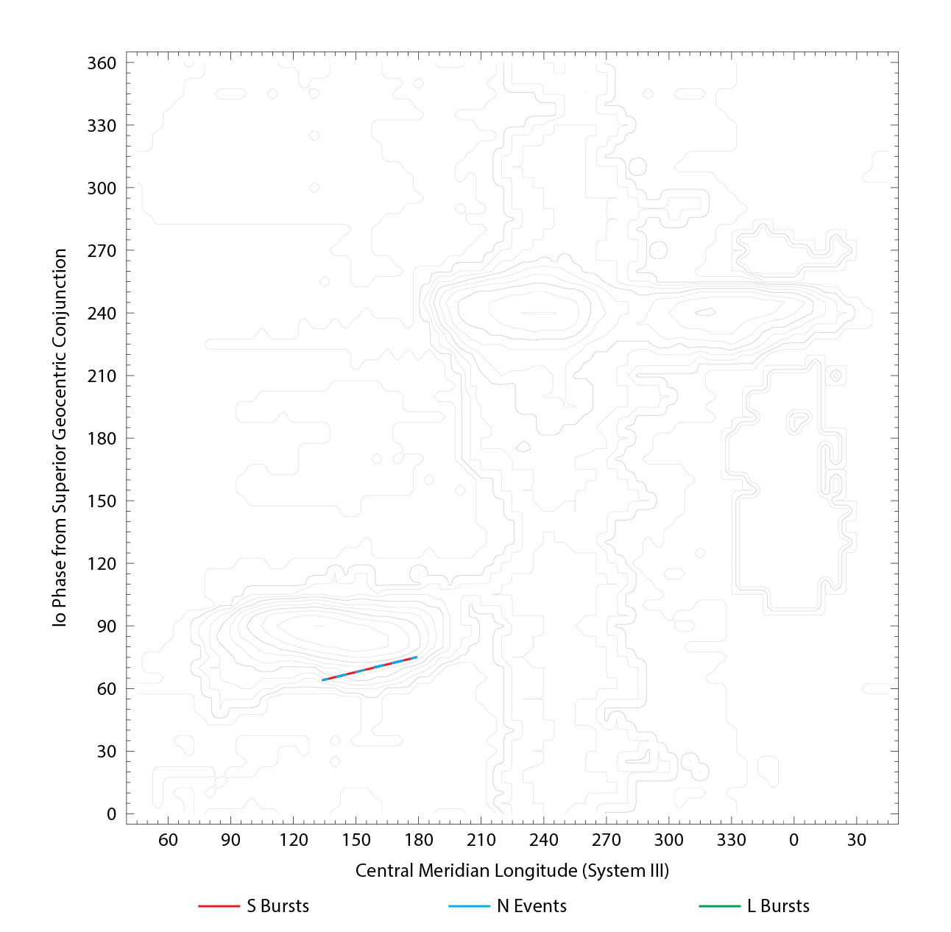

RJP Sky View

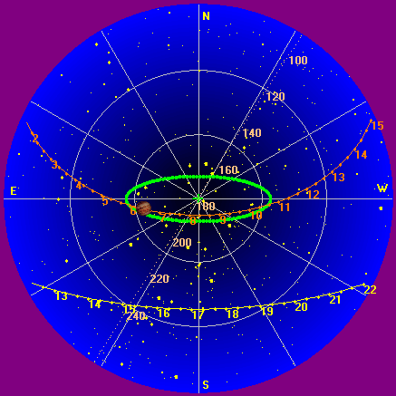

US-TEC Map

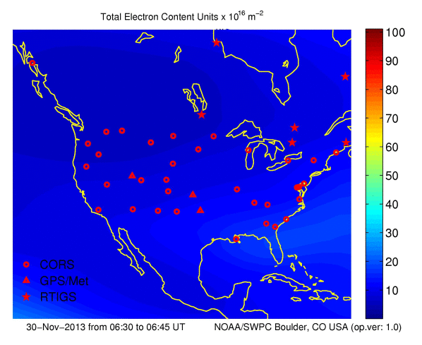

Kp index, 3-hour average: | data not available

CONUS Lightning Activity

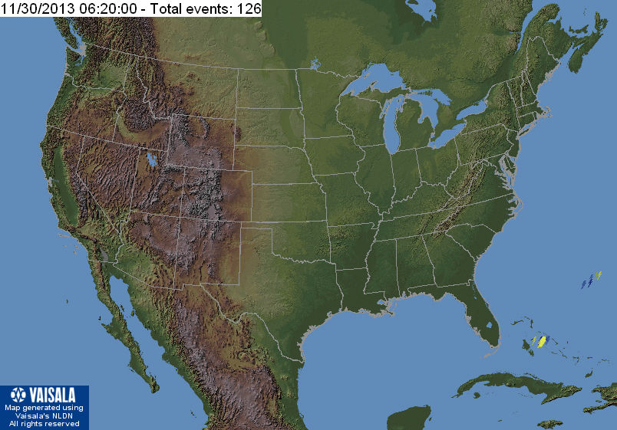

Instrumentation: | DPS on XTFD  60 kHz IF  300 channels, 53 kHz spacing  17–33 MHz

Calibration Scale

Overview Spectrogram (700 px)

