TWB Observation Target Dec 12, 2014 – Thursday night / Friday morning
Beam Steering 15° S, 0° EW On Duty: 0800UTC / 0300 LOCAL

Phase plane at transit 0948 UTC
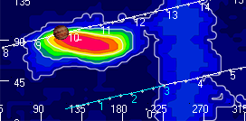

TFD Array 20 MHz HPBW 15° NS x 35° EW
