TWB Observation Report — 22 Dec 2013

Observatory: | AJ4CO Observatory | Instrumentation: | TWB on TFD Array RCP
Location: | High Springs, Florida |  | DPS on TFD Array RCP / LCP
Observer: | Dave Typinski |  | FS-200 on TFD Array RCP+LCP

Observer On Duty (UTC): | 0500 | Body: | Jupiter
Observer Off Duty (UTC): | 0900 | Storm Type: | Io-A/C

Storm Activity (UTC) |  | CML-III | Io φ | Off Axis | D_{E} | JS ∠ | Δ JE
Begin: | 0535 | 199° | 222° | 17° | +1.62° | –163° | 4.24 AU
End: | 0850 | 316° | 250° | 30° | +1.62° | –163° | 4.24 AU

Interval |  |  |  |  |  | F_{hi} | F_{lo} |  |  |  | Drift |  | Rot Rate | TEC
# | (UTC) | L | S | N | Pol | MHz | MHz | CML | Io | ML | MHz/sec | FB | #/MHz @ F | 10¹⁶/m²
1 | 0733–0739 |  | X |  | RCP | 22 | 17 | 272° | 239° |  |  |  |  | 13.4
2
3
4
5
6

Interval – Time during which something interesting was observed  L, S, N – Indicates presence of L bursts, S bursts, and N events  Pol – Dominant circular polarization observed  Fhi, Flo – Frequency range of observed emission  CML, Io – System III CML and Io phase during noted interval | ML – indicates presence of modulation lanes  Drift – Observed modulation lane drift rate in MHz per minute  FB – indicates presence of Faraday bands  Rot Rate – Observed Faraday rotation rate in rotations per MHz at observing frequency F  TEC – Ionospheric vertical total electron count during noted interval as reported by NGDC

Observer Notes
Io-A from 0530 to 0830 was RCP L bursting from 17 to 33 MHz, but mostly below 27 MHz.
One period of nice S bursting from 0733 to 0739 covering 17 to 22 MHz.
Looked like a very brief N event from 0612 to 0613 at 23 MHz.
Very distinct negatively sloping modulation lanes form 0714 to 0718.
Io-C, around 0845, was very weak and also RCP, all below 23 MHz.

Data File(s): | 11 Gage data files  AJ4CO-DPS-131222053000.sps  AJ4CO-FS-200-131222053000.sps

Io-CML Phase Plane

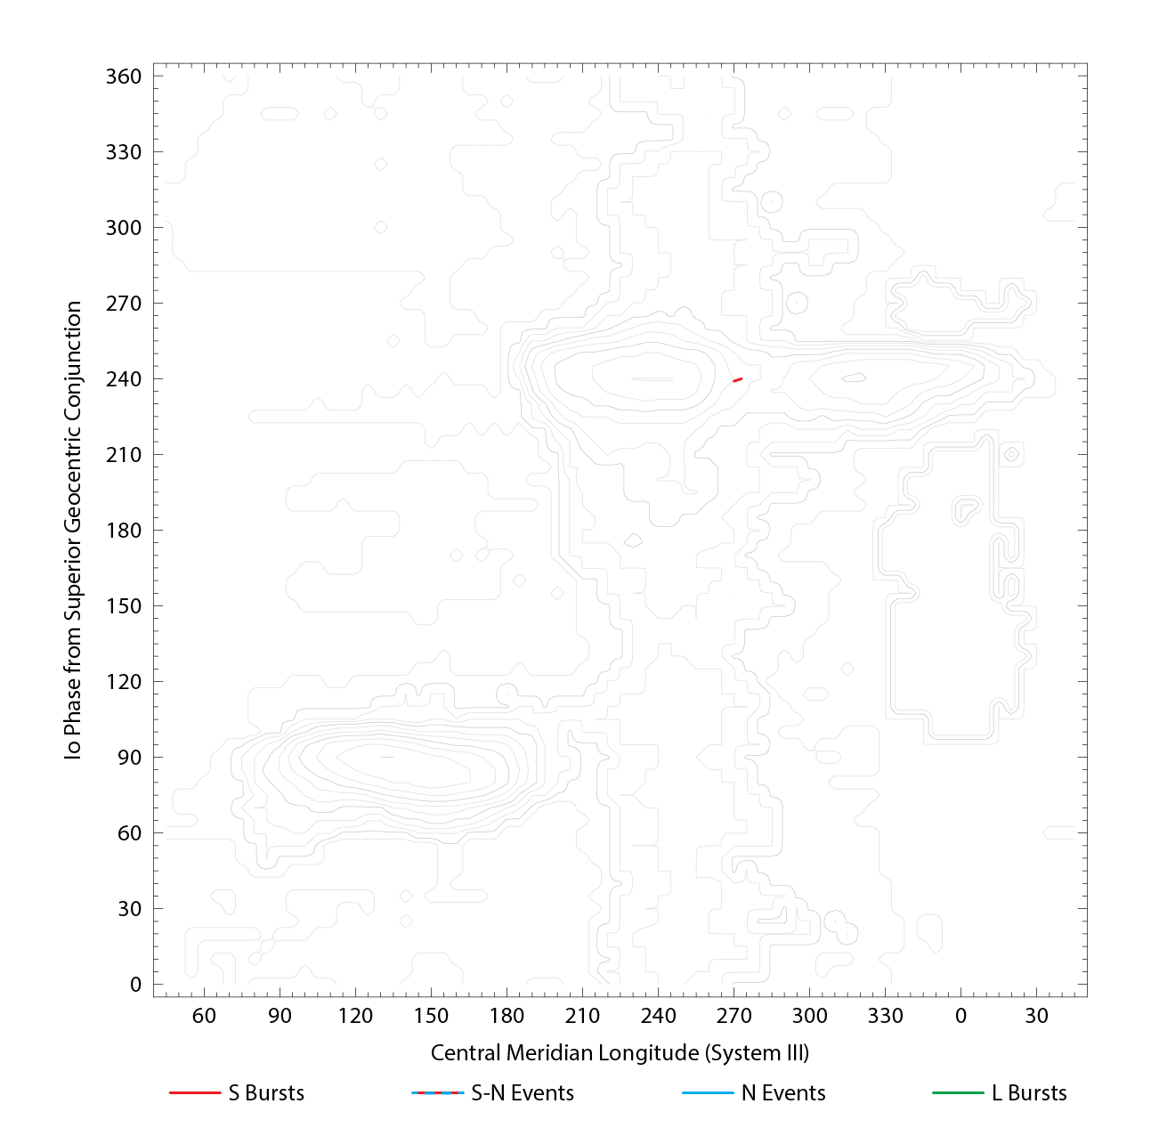

RJP Sky View

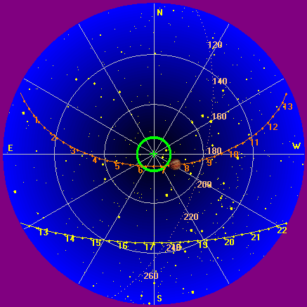

US-TEC Map
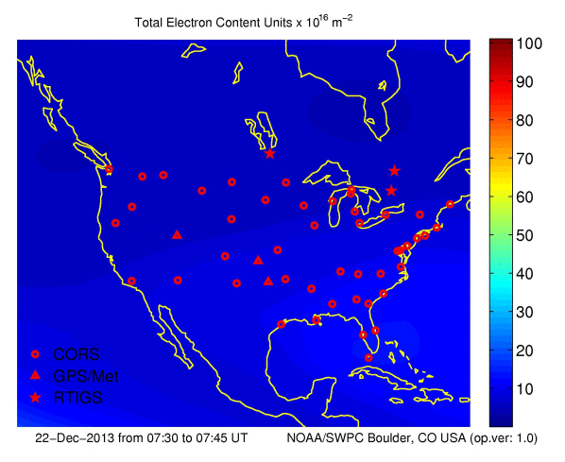
Kp index, 3-hour average: | 1

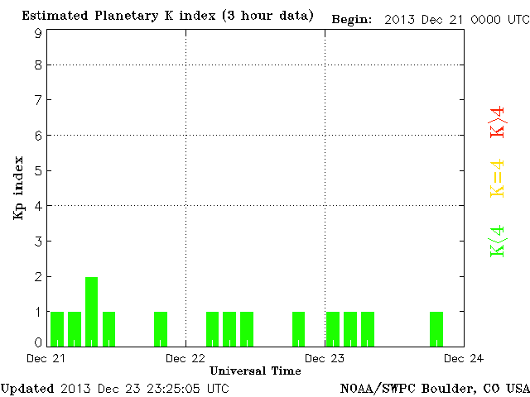

CONUS Lightning Activity

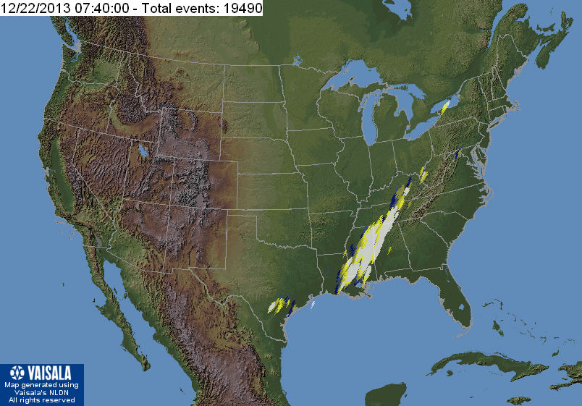

Instrumentation: | DPS on XTFD  60 kHz IF  300 channels, 53 kHz spacing  17–33 MHz

Calibration Scale

Overview Spectrograms (700 px)

