TWB Observation Report — 15 Dec 2013

Observatory: | AJ4CO Observatory | Instrumentation: | TWB on TFD Array RCP
Location: | High Springs, Florida |  | Gage CS1220 Digitizer
Observer: | Dave Typinski |  | DPS on TFD Array

Observer On Duty (UTC): | 0430 | Body: | Jupiter
Observer Off Duty (UTC): | 0745 | Storm Type: | Io-A

Storm Activity (UTC) |  | CML-III | Io φ | Off Axis | D_{E} | JS ∠ | Δ JE
Begin: | 0500 | 202° | 232° | 15° | +1.61° | –155° | 4.28 AU
End: | 0715 | 284° | 251° | 3° | +1.61° | –155° | 4.28 AU

Interval |  |  |  |  |  | F_{hi} | F_{lo} |  |  |  | Drift |  | Rot Rate | TEC
# | (UTC) | L | S | N | Pol | MHz | MHz | CML | Io | S | MHz/sec | FB | #/MHz @ F | 10¹⁶/m²
1 |  |  |  |  |  |  |  |  |  |  |  |  |  | 13.8
2
3
4
5
6

Interval – Time during which something interesting was observed  L, S, N – Indicates presence of L bursts, S bursts, and N events  Pol – Dominant circular polarization observed  Fhi, Flo – Frequency range of observed emission  CML, Io – System III CML and Io phase during noted interval | ML – indicates presence of modulation lanes  Drift – Observed modulation lane drift rate in MHz per minute  FB – indicates presence of Faraday bands  Rot Rate – Observed Faraday rotation rate in rotations per MHz at observing frequency F  TEC – Ionospheric vertical total electron count during noted interval as reported by NGDC

Observer Notes
L bursting.

Beam steered-TFD array seems to possibly produce Faraday like banding in its output—check against zenith steered array for Io-A on 12/22/13.

Data File(s): | AJ4CO-DPS-131215050000.sps  plus 33 Gage data files

Io-CML Phase Plane

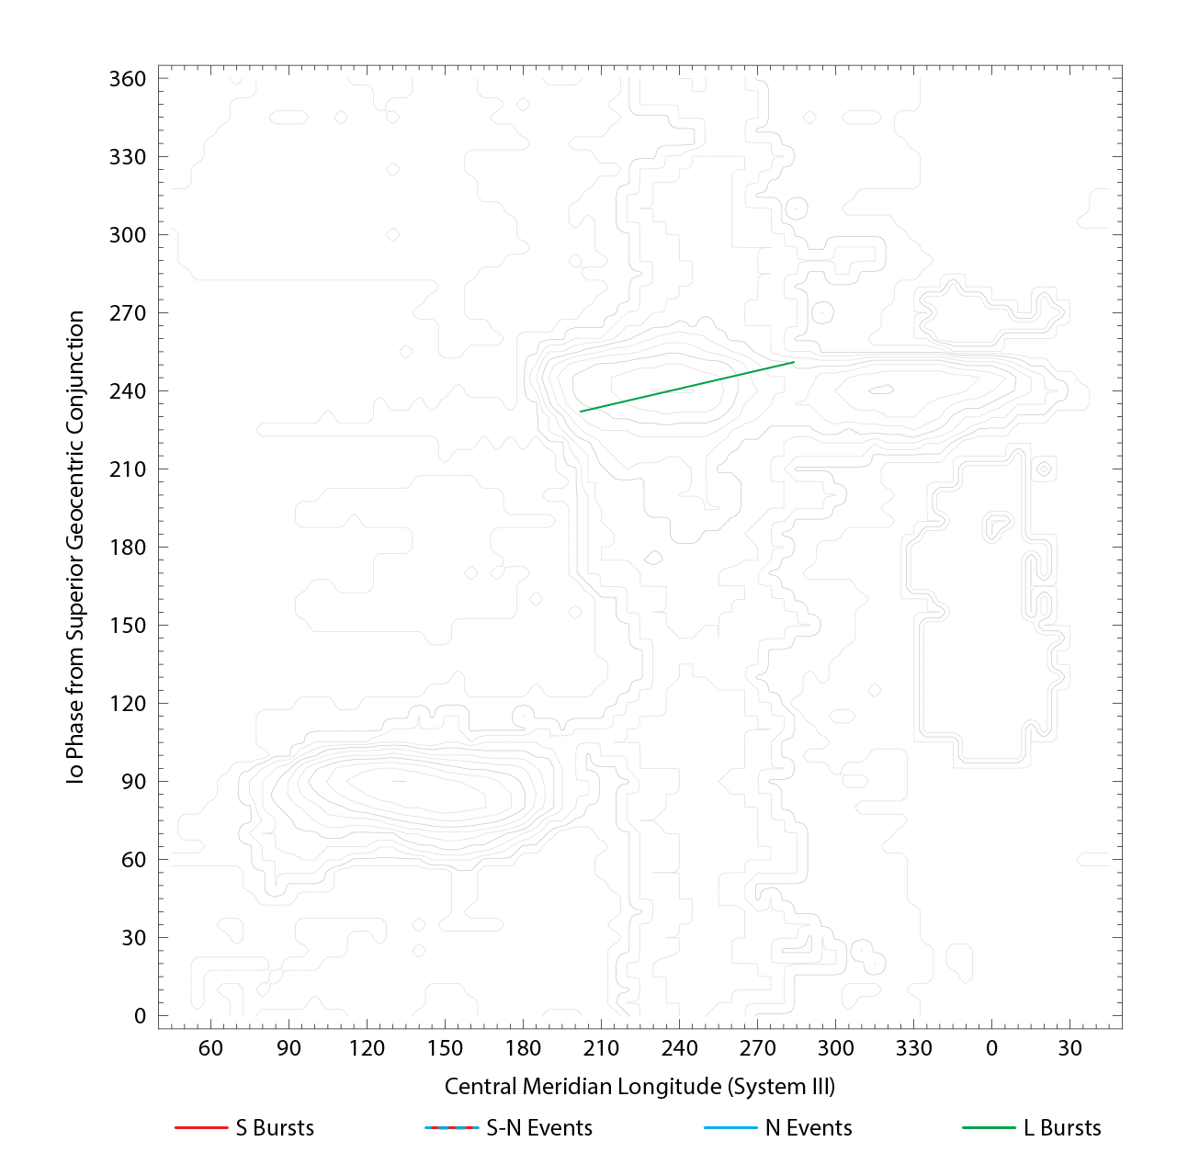

RJP Sky View

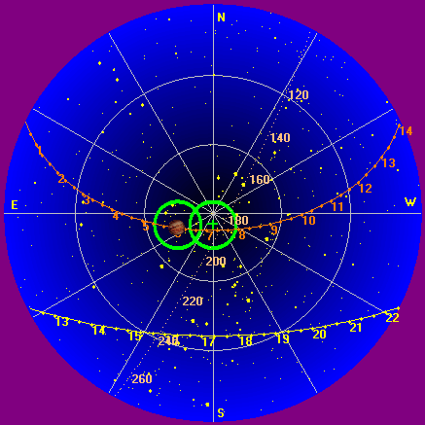

US-TEC Map
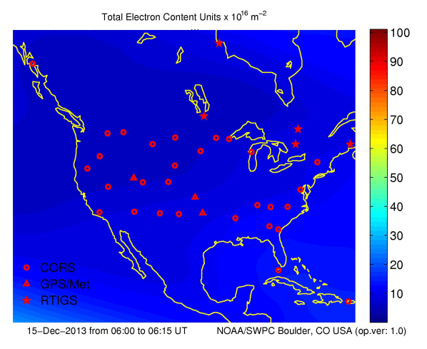
Kp index, 3-hour average: | 1

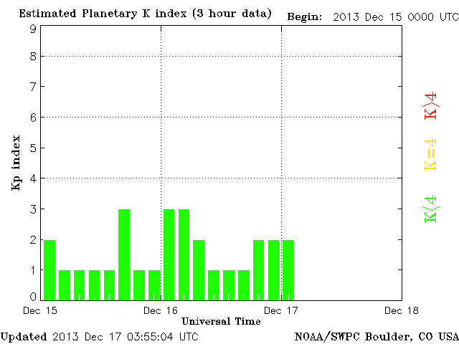

CONUS Lightning Activity

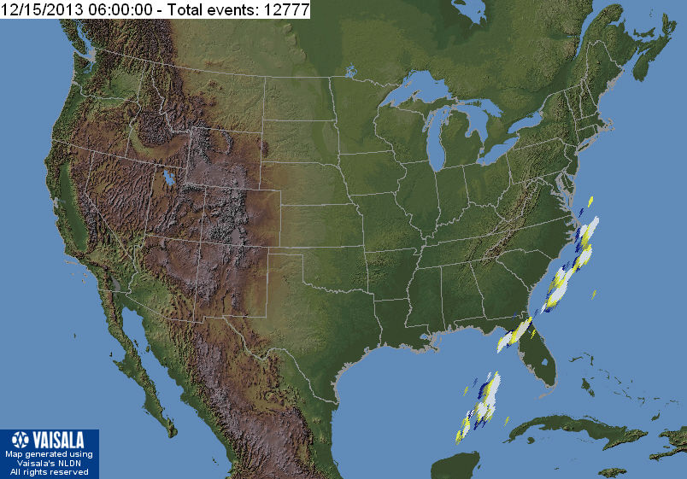

Instrumentation: | DPS on XTFD  60 kHz IF  300 channels, 53 kHz spacing  17–33 MHz

Calibration Scale

Overview Spectrograms (700 px)

