TWB Observation Report — 08 Dec 2013

Observatory: | AJ4CO Observatory | Instrumentation: | TWB on TFD Array RCP
Location: | High Springs, Florida |  | Gage CS1220 Digitizer
Observer: | Dave Typinski |  | DPS on TFD Array

Observer On Duty (UTC): | 0350 | Body: | Jupiter
Observer Off Duty (UTC): | 0615 | Storm Type: | Io-A/C

Storm Activity (UTC) |  | CML-III | Io φ | Off Axis | D_{E} | JS ∠ | Δ JE
Begin: | 0400 | 191° | 238° | 51° | +1.61° | –147° | 4.33 AU
End: | 0715 | 309° | 266° | 10° | +1.61° | –147° | 4.33 AU

Interval |  |  |  |  |  | F_{hi} | F_{lo} |  |  |  | Drift |  | Rot Rate | TEC
# | (UTC) | L | S | N | Pol | MHz | MHz | CML | Io | S | MHz/sec | FB | #/MHz @ F | 10¹⁶/m²
1 | 0520–0600 | X |  |  | RCP | 17 | 26 | 250° | 252° |  |  |  |  | 17.1
2
3
4
5
6

Interval – Time during which something interesting was observed  L, S, N – Indicates presence of L bursts, S bursts, and N events  Pol – Dominant circular polarization observed  Fhi, Flo – Frequency range of observed emission  CML, Io – System III CML and Io phase during noted interval | ML – indicates presence of modulation lanes  Drift – Observed modulation lane drift rate in MHz per minute  FB – indicates presence of Faraday bands  Rot Rate – Observed Faraday rotation rate in rotations per MHz at observing frequency F  TEC – Ionospheric vertical total electron count during noted interval as reported by NGDC

Observer Notes
The TFD array does not do well with off-axis angles > 30°. This is due to the way the beam changes shape with frequency and off-axis angle.

First-look analysis of the high speed data evinced some weak S bursts mixed with L bursts ca. 0530.

Data File(s): | AJ4CO-DPS-131208040000.sps  plus 32 Gage data files

Custom Interval Ephemerides
 | Start Dates: | 12/8/13 |  |  |  | 12/8/13
 | & End Times: | 04:00:00 |  |  |  | 07:15:00
 |  | Interval Start |  | Interval Center |  | Interval End
Date |  | 08 Dec 2013 |  | 08 Dec 2013 |  | 08 Dec 2013
UTC |  | 04:00:00 |  | 05:37:30 |  | 07:15:00
JDE |  | 2456634.66746 |  | 2456634.73517 |  | 2456634.80288
Local (UTC-4) |  | 00:00:00 |  | 01:37:30 |  | 03:15:00
LMST |  | 03:37:49 |  | 05:15:35 |  | 06:53:21
 |  | Jupiter |  | Jupiter |  | Jupiter
Alt ° |  | +39.499 |  | +60.662 |  | +79.983
Az ° |  | +84.790 |  | +97.634 |  | +138.308
HA hms |  | - 03:44:18 |  | - 02:06:30 |  | - 00:28:42
Off Axis ° |  | +50.501 |  | +29.338 |  | +10.017
RA hms |  | - 16:37:52.8673 |  | - 16:37:54.5371 |  | - 16:37:56.2098
Dec ° |  | +22.1630688 |  | +22.1641406 |  | +22.1652138
Rise UTC |  | 0049 (2049 L) |  | 0049 (2049 L) |  | 0049 (2049 L)
Trans UTC |  | 0743 (0343 L) |  | 0743 (0343 L) |  | 0743 (0343 L)
Set UTC |  | 1437 (1037 L) |  | 1437 (1037 L) |  | 1437 (1037 L)
De ° |  | +1.61176550 |  | +1.61176885 |  | +1.61177245
Δ J-E AU |  | +4.32725188 |  | +4.32669846 |  | +4.32614622
J-E ∠° |  | +26.83062 |  | +26.76751 |  | +26.70440
€
Ds ° |  | +1.76367034 |  | +1.76341563 |  | +1.76316089
Δ J-S AU |  | +5.183374472 |  | +5.183399477 |  | +5.183424481
J-S ∠° |  | - 147.27193 |  | - 147.34724 |  | - 147.42255
CML-III ° |  | +191.458 |  | +250.410 |  | +309.361
Io SGC ° |  | +238.151 |  | +251.902 |  | +265.628
Io λ (III) °

Io-CML Phase Plane

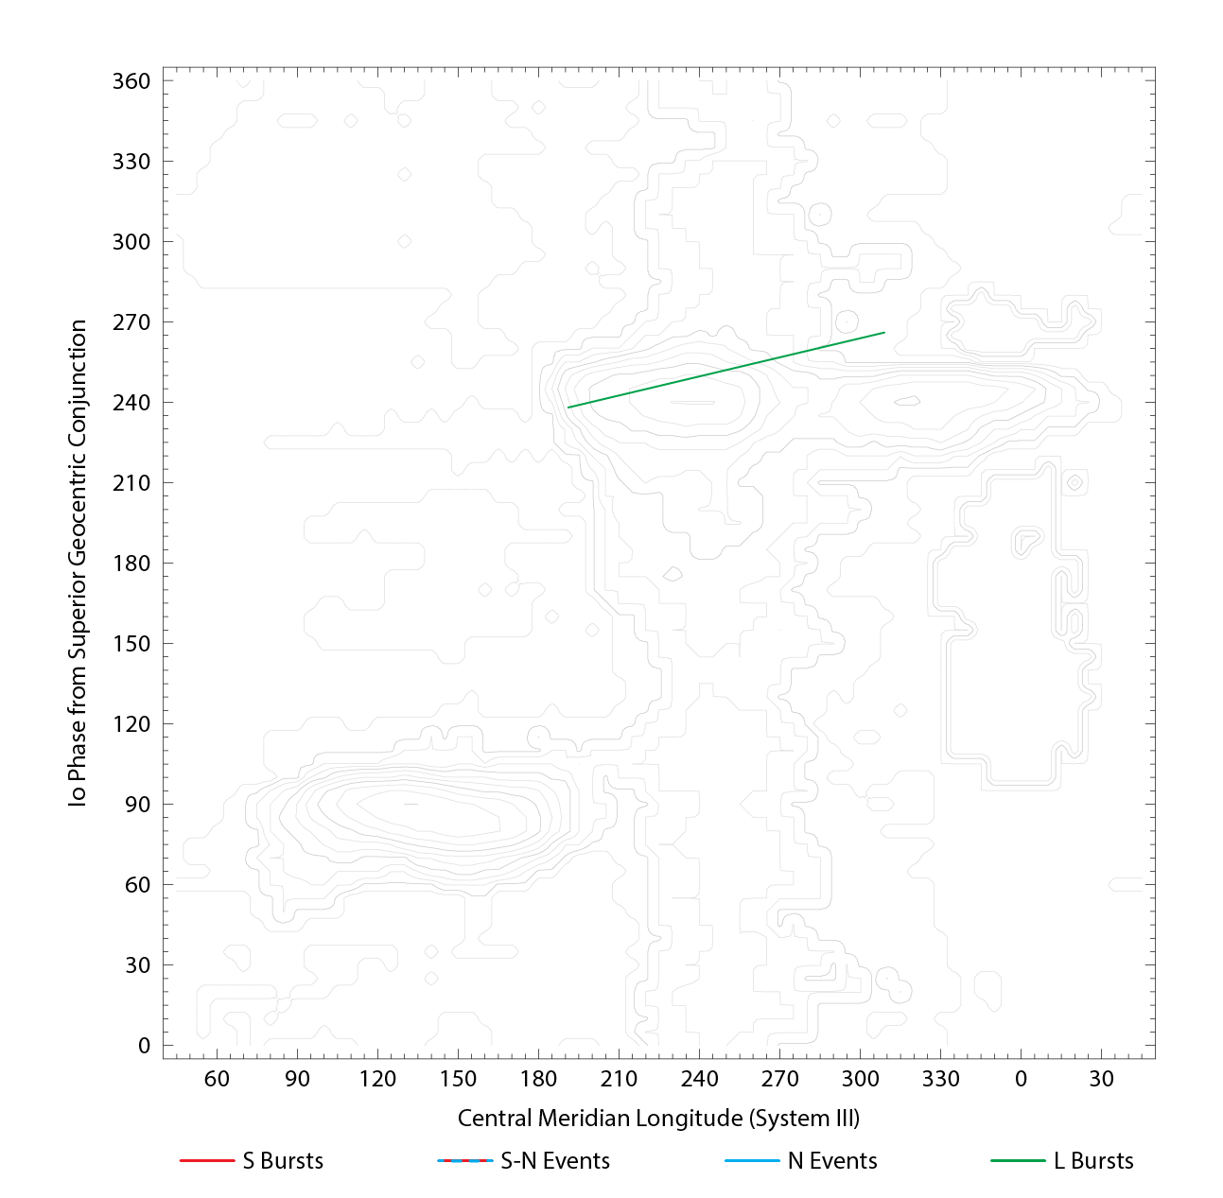

RJP Sky View

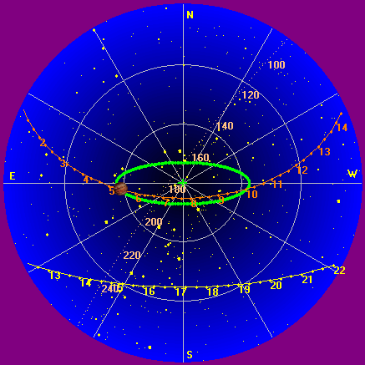

US-TEC Map
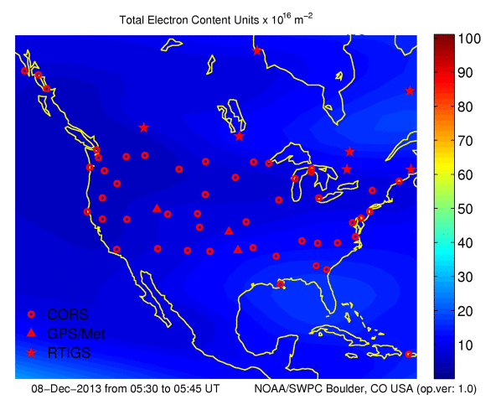
Kp index, 3-hour average: | 5

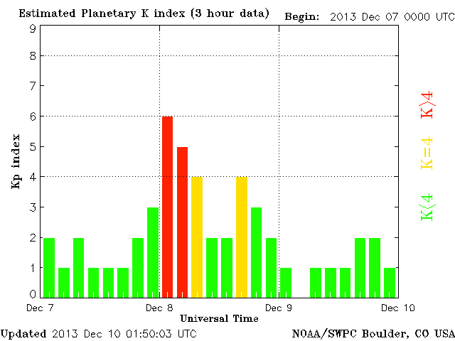

CONUS Lightning Activity

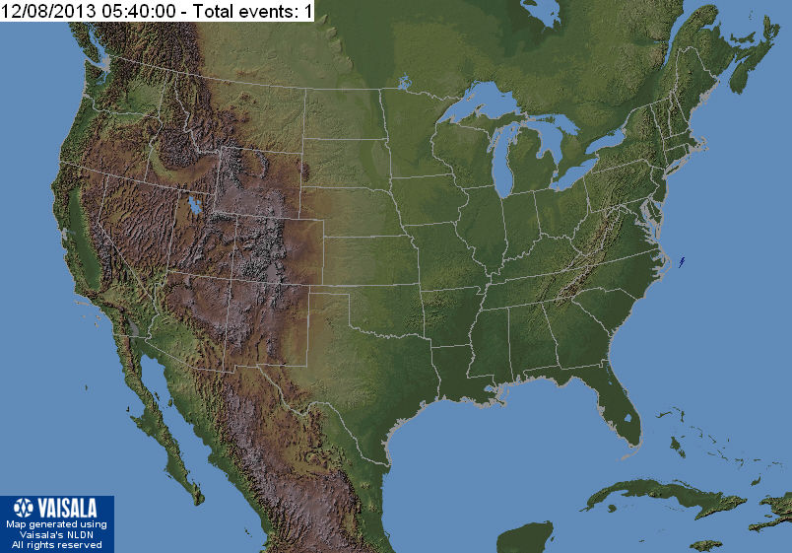

Instrumentation: | DPS on XTFD  60 kHz IF  300 channels, 53 kHz spacing  17–33 MHz

Calibration Scale

Overview Spectrogram (700 px)

