TWB Observation Target Jan 26, 2015 – Monday night / Tuesday morning
Beam Steering 15° S, 0° EW On Duty: 0400UTC / 2300 LOCAL

Phase plane at transit 0637 UTC
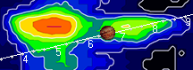

TFD Array 20 MHz HPBW 15° NS x 35° EW
