TWB Observation Target Jan 19, 2015 – Sunday night / Monday morning
Beam Steering 15° S, 0° EW On Duty: 0300UTC / 2200 LOCAL

Phase plane at transit 0708 UTC
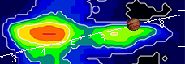

TFD Array 20 MHz HPBW 15° NS x 35° EW
