TWB Observation Report — 30 Jan 2014

Observatory: | AJ4CO Observatory | Instrumentation: | TWB on TFD Array LCP
Location: | High Springs, Florida |  | DPS on TFD Array RCP / LCP
Observer: | Dave Typinski |  | FS-200 on TFD Array LCP

Observer On Duty (UTC): | 0230 | Body: | Jupiter
Observer Off Duty (UTC): | 0640 | Storm Type: | Io-C

Storm Activity (UTC) |  | CML-III | Io φ | Off Axis | D_{E} | JS ∠ | Δ JE
Begin: | 0349 | 250° | 228° | < 15° | +1.65° | +152° | 4.31 AU
End: | 0710 | 11° | 256° | < 15° | +1.65° | +152° | 4.31 AU

Interval |  |  |  |  |  | F_{hi} | F_{lo} |  |  |  | Drift |  | Rot Rate | TEC
# | (UTC) | L | S | N | Pol | MHz | MHz | CML | Io | ML | MHz/sec | FB | #/MHz @ F | 10¹⁶/m²
1 | 0349–0710 | X | X | X | LCP | 16 | 23+ |  |  |  |  |  |  | 8.8
2
3
4
5
6

Interval – Time during which something interesting was observed  L, S, N – Indicates presence of L bursts, S bursts, and N events  Pol – Dominant circular polarization observed  Fhi, Flo – Frequency range of observed emission  CML, Io – System III CML and Io phase during noted interval | ML – indicates presence of modulation lanes  Drift – Observed modulation lane drift rate in MHz per minute  FB – indicates presence of Faraday bands  Rot Rate – Observed Faraday rotation rate in rotations per MHz at observing frequency F  TEC – Ionospheric vertical total electron count during noted interval as reported by NGDC

Observer Notes
Almost all S bursting and SN events from 16 to 23+ MHz.
Very long-lived N event between 20 and 22 MHz.
The RCP emission - ostensibly from the A source -- continued well into the nominal Io-C region.
The LCP emission -- ostensibly from the C source -- started very early, well within the Io-A region.
Modulation lanes were absent except last half hour of the storm as the S bursting and SN events gave way to L bursting.
Beam steering: 0000 5S 0EW 0223 5S 15E 0310 5S 0EW 0452 5S 30W

Data File(s): | 65 Gage data files  AJ4CO-DPS-140130044000.sps  AJ4CO-FS-200-140130044000.sps

Io-CML Phase Plane

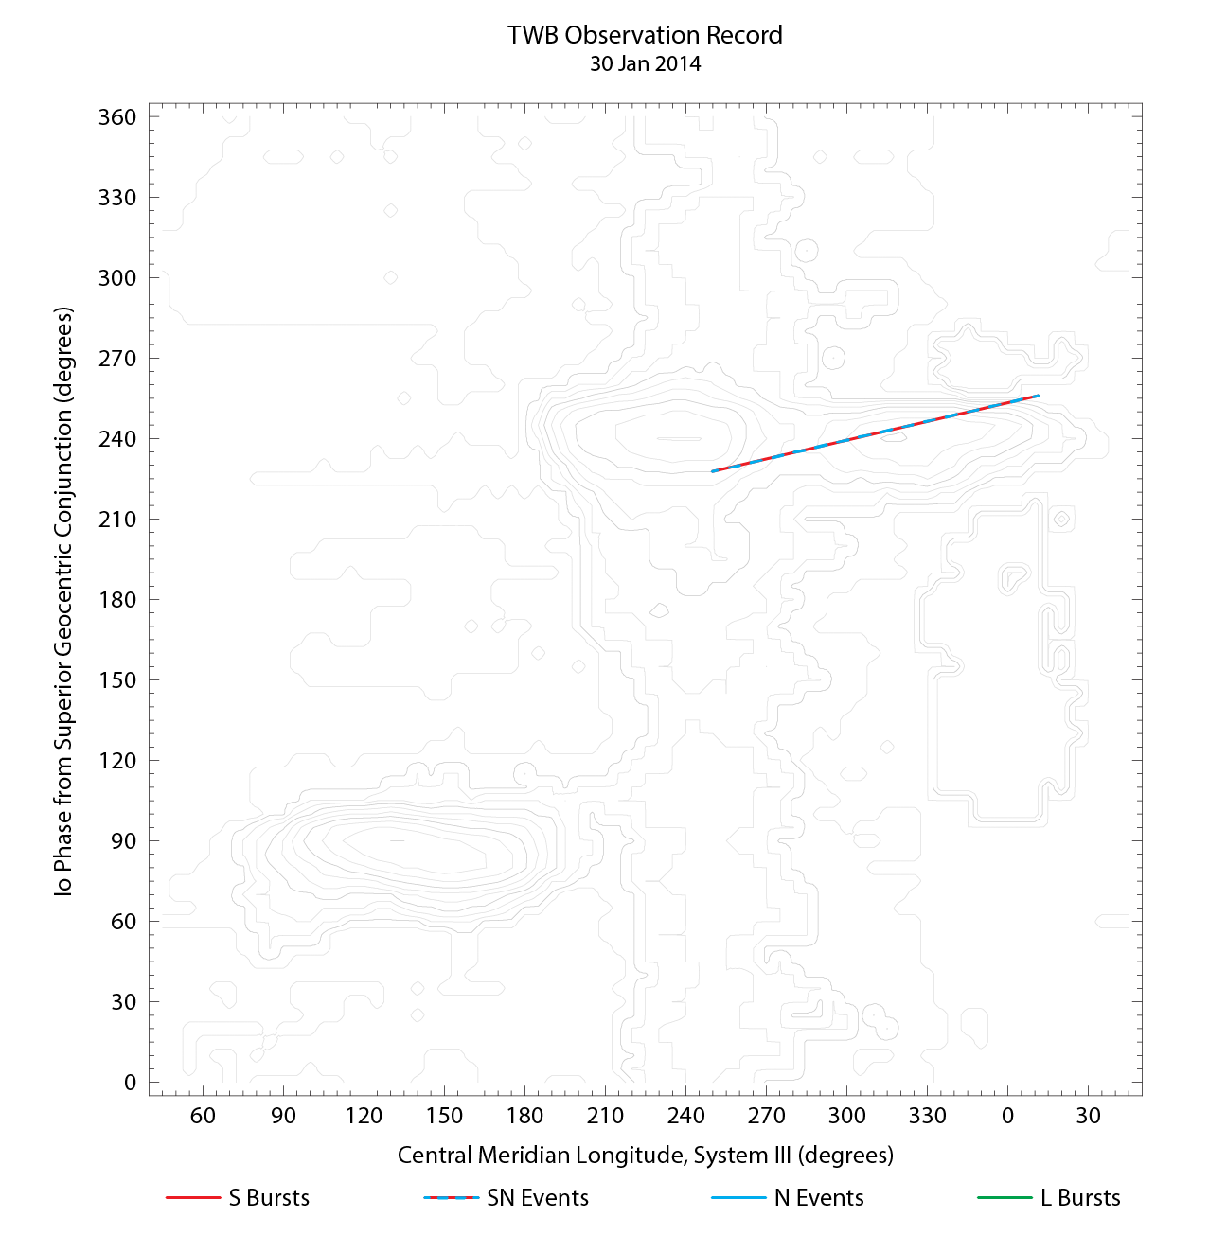

RJP Sky View

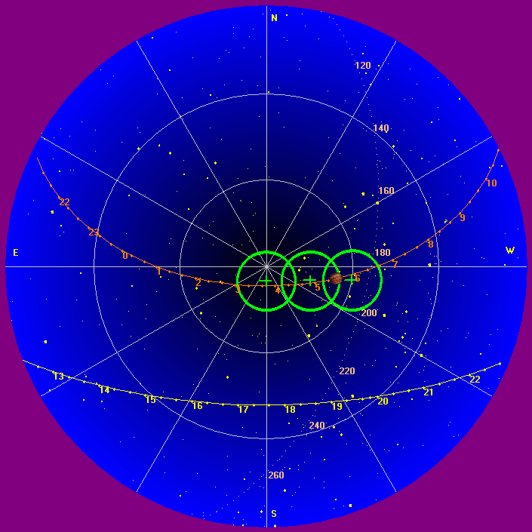

US-TEC Map
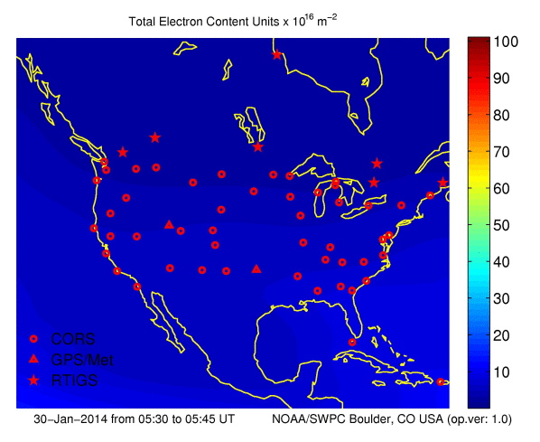
Kp index, 3-hour average: (historical) | 1

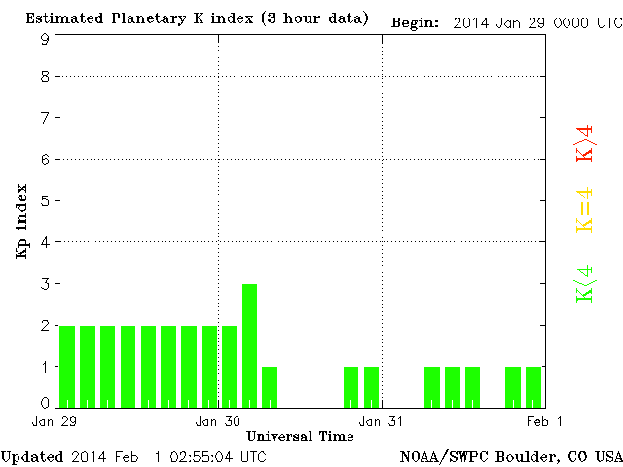

CONUS Lightning Activity

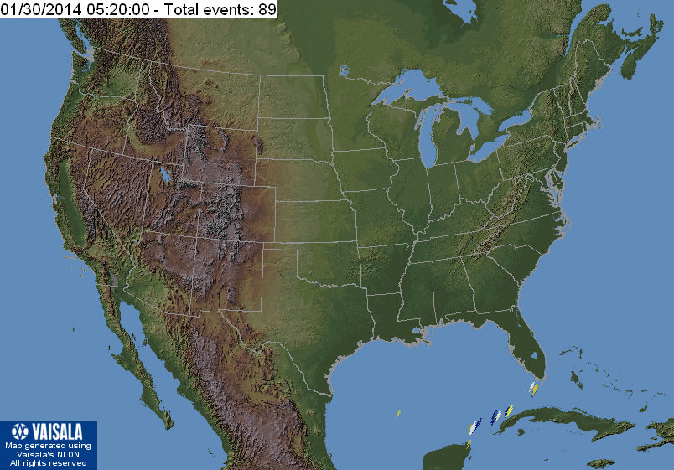

Instrumentation: | DPS on XTFD  60 kHz IF  300 channels, 53 kHz spacing  17–33 MHz

Calibration Scale

Overview Spectrograms (700 px)

