TWB Observation Report — 29 Dec 2013

Observatory: | AJ4CO Observatory | Instrumentation: | TWB on TFD Array RCP
Location: | High Springs, Florida |  | DPS on TFD Array RCP / LCP
Observer: | Dave Typinski |  | FS-200 on TFD Array RCP+LCP

Observer On Duty (UTC): | 0545 | Body: | Jupiter
Observer Off Duty (UTC): | 1100 | Storm Type: | Io-A/C

Storm Activity (UTC) |  | CML-III | Io φ | Off Axis | D_{E} | JS ∠ | Δ JE
Begin: | 0620 | 200° | 214° | 12° | +1.62° | –171° | 4.22 AU
End: | 1100 | 9° | 254° | 14° | +1.62° | –171° | 4.22 AU

Interval |  |  |  |  |  | F_{hi} | F_{lo} |  |  |  | Drift |  | Rot Rate | TEC
# | (UTC) | L | S | N | Pol | MHz | MHz | CML | Io | ML | MHz/sec | FB | #/MHz @ F | 10¹⁶/m²
1 | 0620–0800 | X |  |  | RCP | 30 | 17 | 230° | 221°
2 | 0730–1100 | X |  |  | LCP | 16 | 23 | 306° | 239°
3 | 0900–1020 |  | X | X | LCP | 15 | 21 | 321° | 243° |  |  |  |  | 11.8
4
5
6

Interval – Time during which something interesting was observed  L, S, N – Indicates presence of L bursts, S bursts, and N events  Pol – Dominant circular polarization observed  Fhi, Flo – Frequency range of observed emission  CML, Io – System III CML and Io phase at middle of noted interval | ML – indicates presence of modulation lanes  Drift – Observed modulation lane drift rate in MHz per minute  FB – indicates presence of Faraday bands  Rot Rate – Observed Faraday rotation rate in rotations per MHz at observing frequency F  TEC – Ionospheric vertical total electron count during noted interval as reported by NGDC

Observer Notes
Io-A
Weak overall, but some periods of stronger activity.
RCP L bursts visible from 17 to 30 MHz, but mostly below 26 MHz.
I'll put forth that the LCP arc starting at 0730 is very early Io-C.
Modulation lanes nicely visible 0730 to 0740.
The array was beam steering in 15° increments, so Jupiter wasn't off axis any more than 10° except for the tail end of Io-C from 0900 to 1100 UTC.
The two sets of vertical parallel lines in the first spectrogram (0650 and 0750 UTC) are when the array was beam steered to a new direction.

Io-C
Lots of LCP SN events and plain S bursting from about 0900 to 1015 UTC. Mostly LCP L bursting after that.
Several periods with RCP L bursts simultaneous with LCP S bursts and SN events. The modulation lanes in the RCP L bursts do not appear to affect the LCP SN events -- which makes sense if they come from two different hemispheres of Jupiter.
During the observation, there was a line of thunderstorms moving in. Lighting was progressively more visible throughout the observation.
The TFD array beam was steered to 60° elevation directly west from 0750 UTC on, as noted above. Jupiter was off axis from 5° to 35°.
Also, this being Io-C, the DPS was reconfigured with a sweep range of 16 to 23 MHz, 300 channels, and a 30 kHz IF BW.

Data File(s): | 71 Gage data files  AJ4CO-DPS-131229061500.sps  AJ4CO-FS-200-131229061500.sps | AJ4CO-DPS-131229083000.sps  AJ4CO-FS-200-131229083000.sps

Io-CML Phase Plane

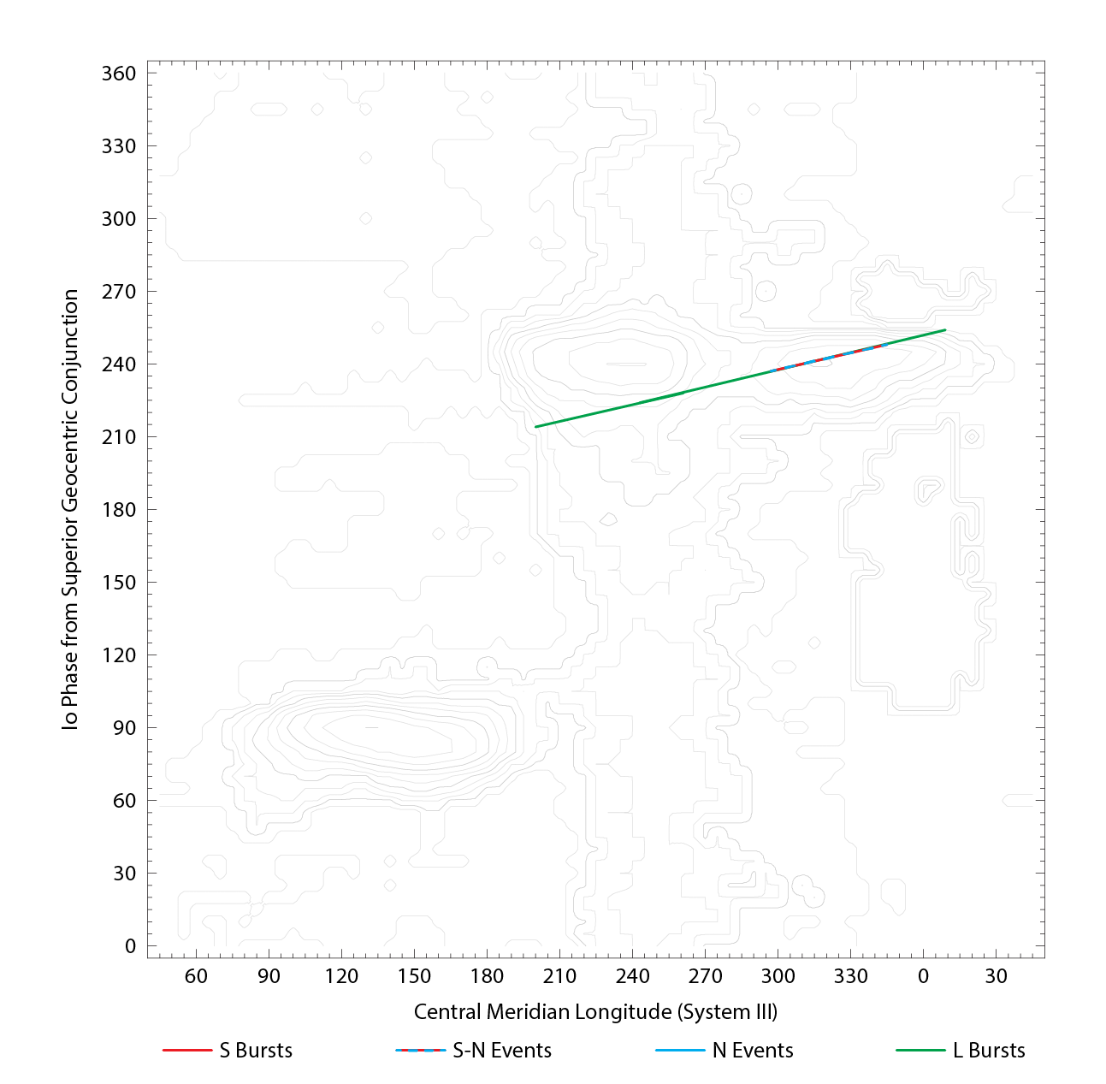

RJP Sky View

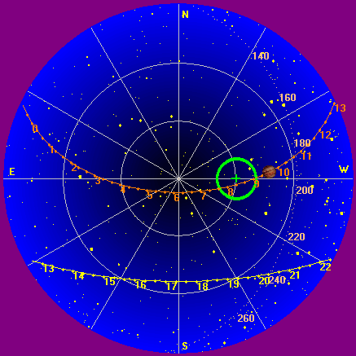

US-TEC Map
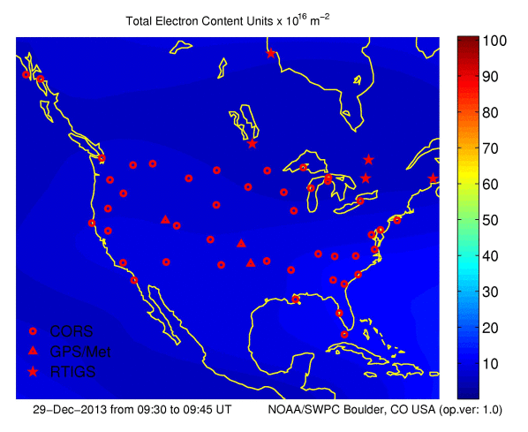
Kp index, 3-hour average: | 2

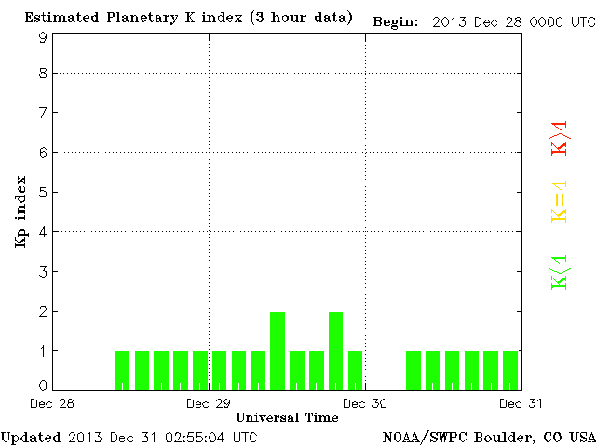

CONUS Lightning Activity

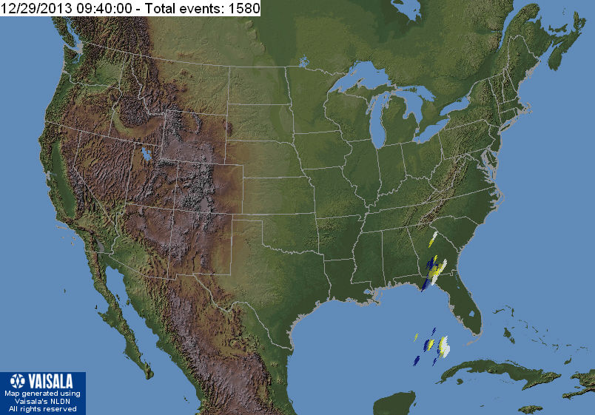

Instrumentation: | DPS on XTFD  60 kHz IF  300 channels, 53 kHz spacing  17–33 MHz

Calibration Scale

Overview Spectrograms (700 px)

Io-A

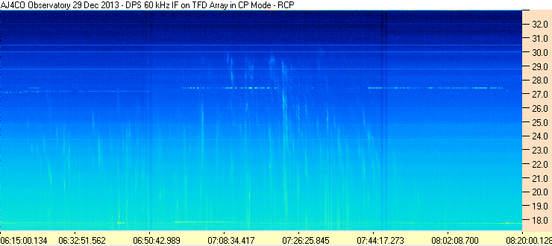
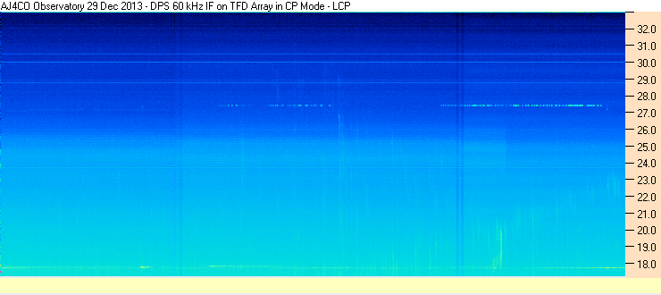

Io-C

